FINAL FAREWELL
FOR DAVID JAMES PEDERSEN
OUR FRIEND
‘ FREAKSHOW ‘
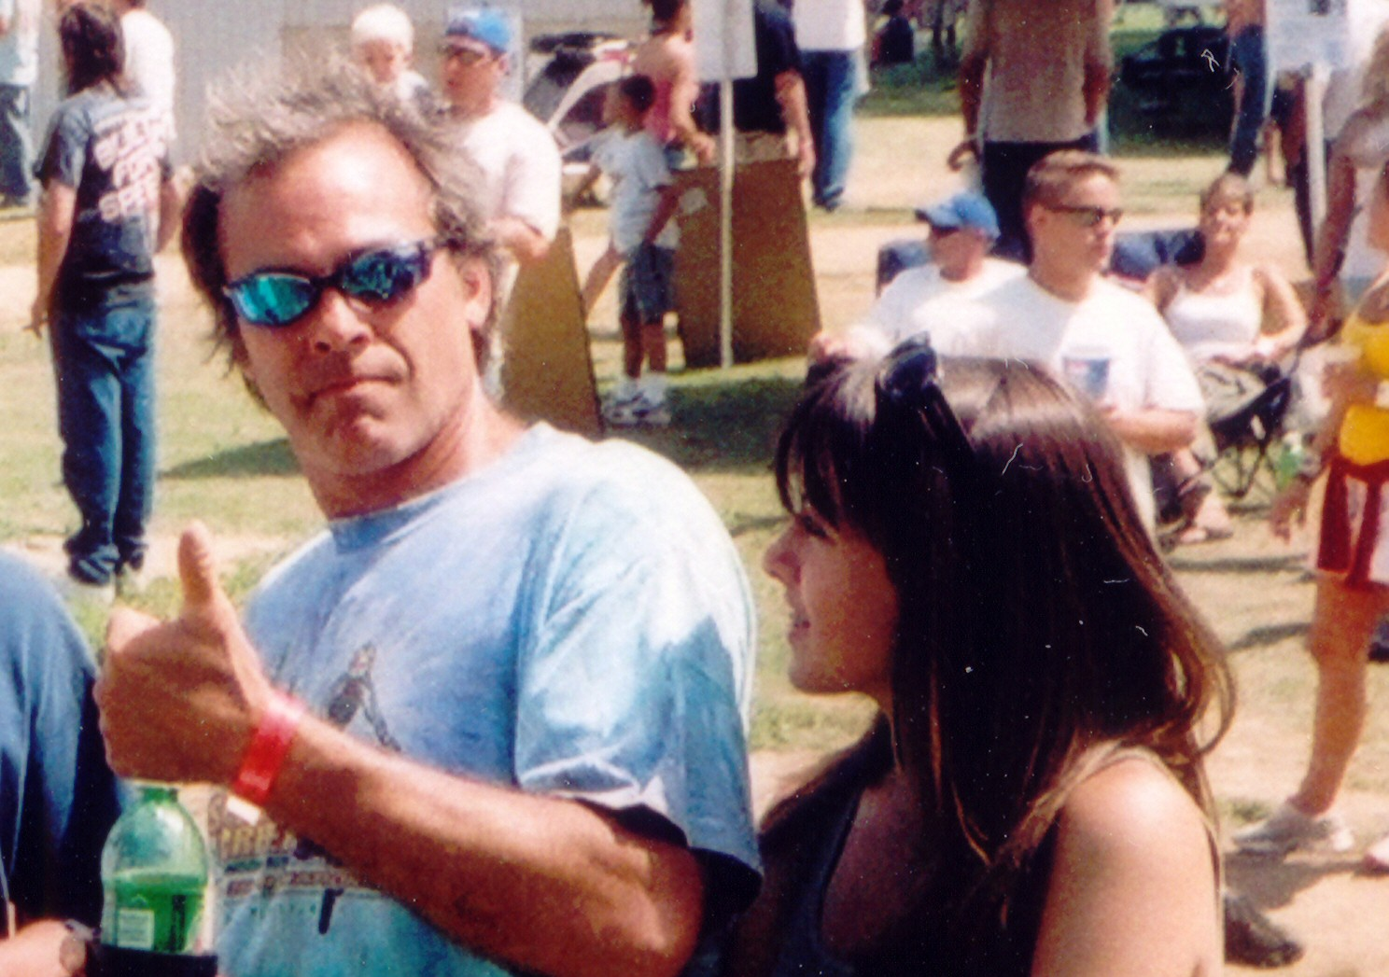
SAT AUGUST 4TH, 3PM AT THE LEONARD BLOOMQUIST RANCH 1320 COUNTY ROAD 14 – EAST END
ATVS, DIRTBIKES, MUDBOGGERS, BOONIE BASHERS, ALL WELCOME!

REV R UP
GET ON DA PIPE – GO FOR THE HOLE SHOT!!!!!

